FastLane Project Report
1. Project Overview
Title and Team Information
- Project Title: FastLane Motors
- Team Members:
  - Prajval Patel - C0911611
  - Urvesh Patel - C0903445
  - Sahil Hamirani - C0911606
  - Akshaybhai Busa - C0908498
Objective
- Provide a seamless experience for clients to inquire about the cars available in stock.
Technology Stack
- MERN Stack: MongoDB, Express.js, React.js, Node.js
Use Case
- Address the problem of car dealerships managing and showcasing their inventory efficiently through a dynamic web application.



2. System Design and Architecture
API Diagram
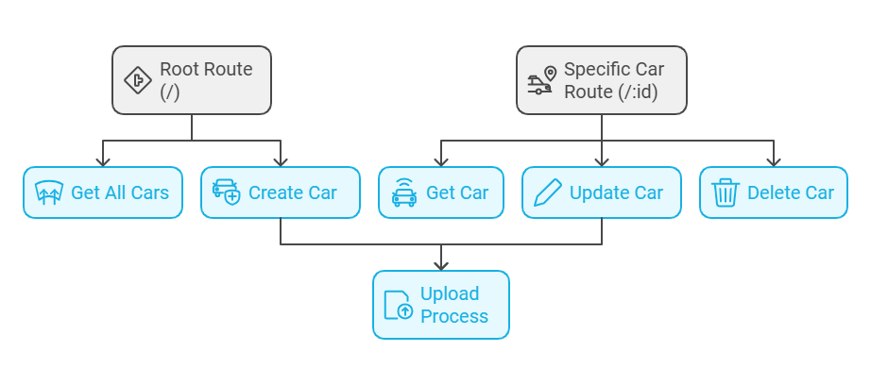Frontend Architecture
- React-based modular components.
- Routing managed by React Router.
Backend Architecture
- RESTful APIs built with Express.js.
- Middleware for image handling and data validation.
Database Design
- Collections:
  - cars: Stores car details including make, model, price, and images.
  - Relationships managed through unique identifiers.
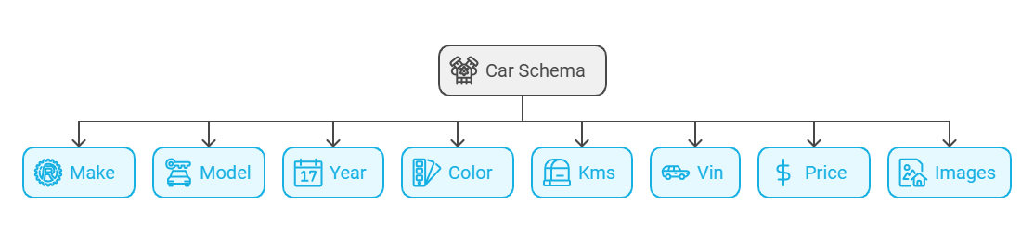
3. Features and Functionalities
Key Features
- Car Listings: Display of cars with filtering options for price and kilometers.
- CRUD Operations: Create, read, update, and delete car records.
- Lease/Finance Calculator: Calculate monthly payments dynamically.
Screenshots
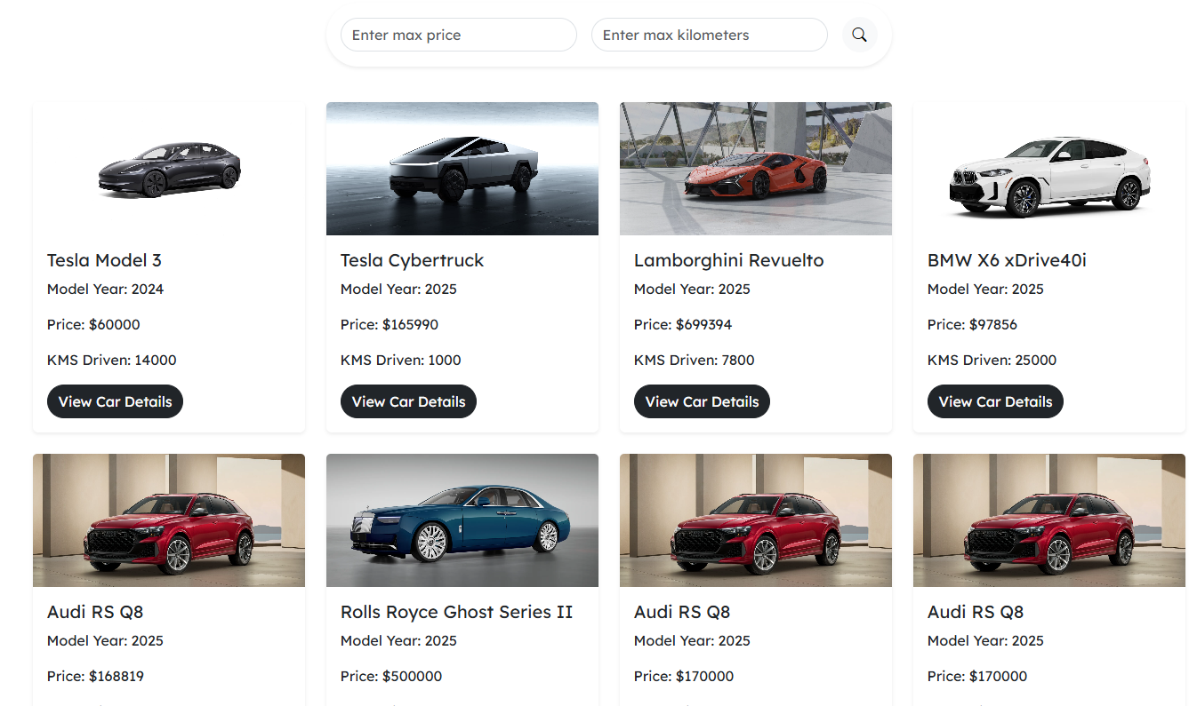

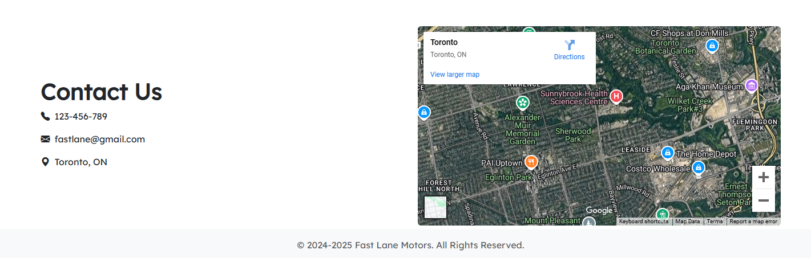
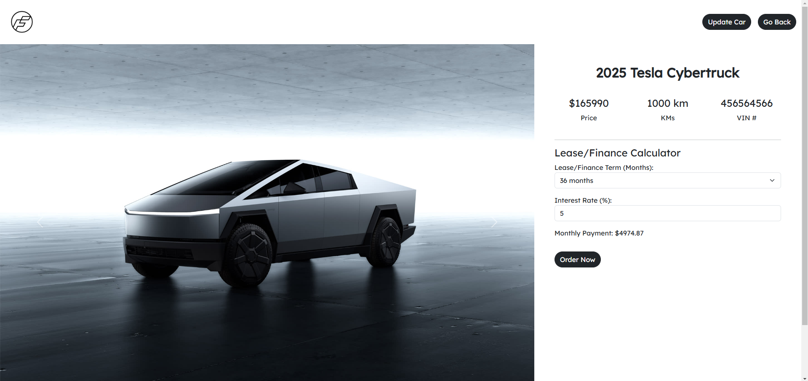
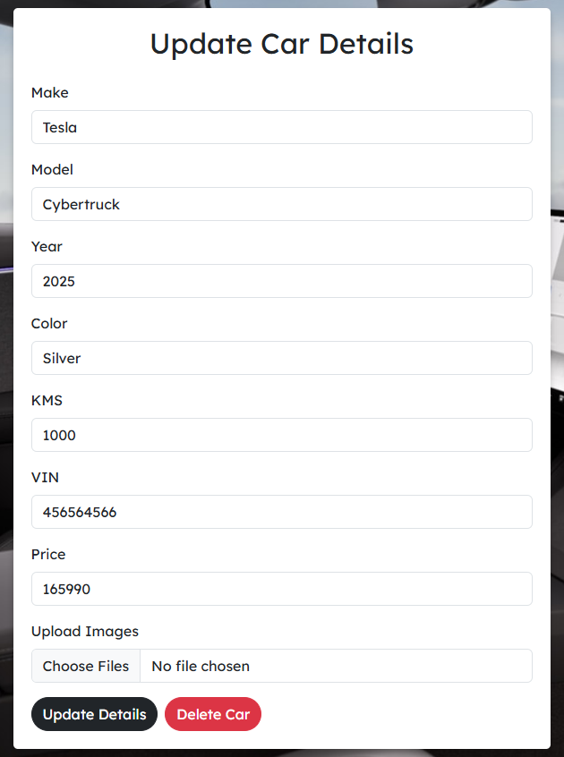
4. Implementation Details
Frontend
- React.js: Dynamic UI rendering.
- Bootstrap: Styling for responsive designs.
- Axios: HTTP client for API communication.
Backend
- Node.js: Handles server-side logic.
- Express.js: RESTful API creation.
- Multer: Middleware for image uploads.
  - https://www.npmjs.com/package/multer
Database
- MongoDB: Schema-less database for scalability.
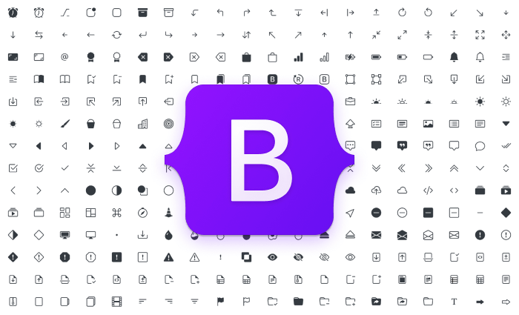

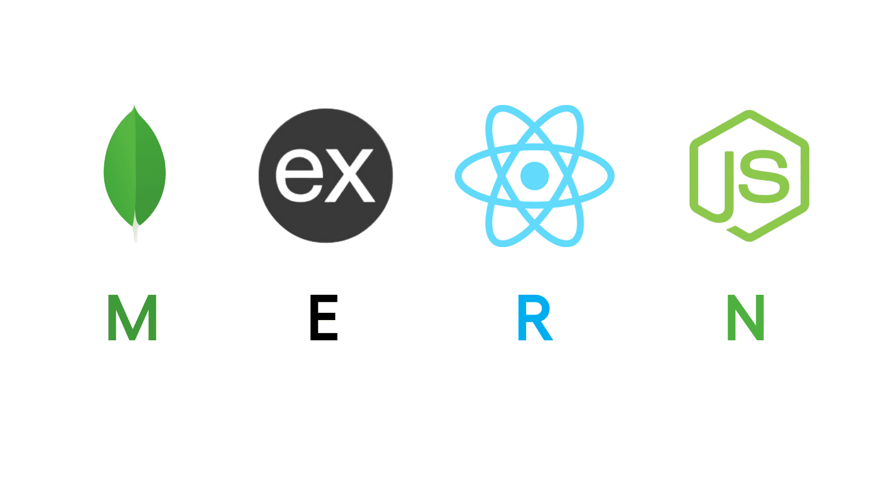
5. Workflow
Typical Workflow
- User performs actions on the frontend.
- API calls sent to the backend via Axios.
- Backend processes requests and interacts with MongoDB.
- JSON responses returned to the frontend for rendering.

Flow Diagram
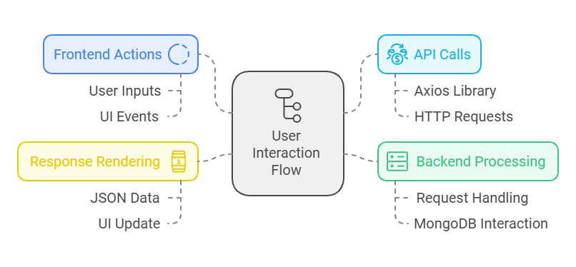

6. Testing and Debugging
Testing
- Unit tests for individual components.
- Integration tests for API endpoints.
Debugging
- Tools used: Postman, Browser DevTools.
- Error logging with meaningful messages.
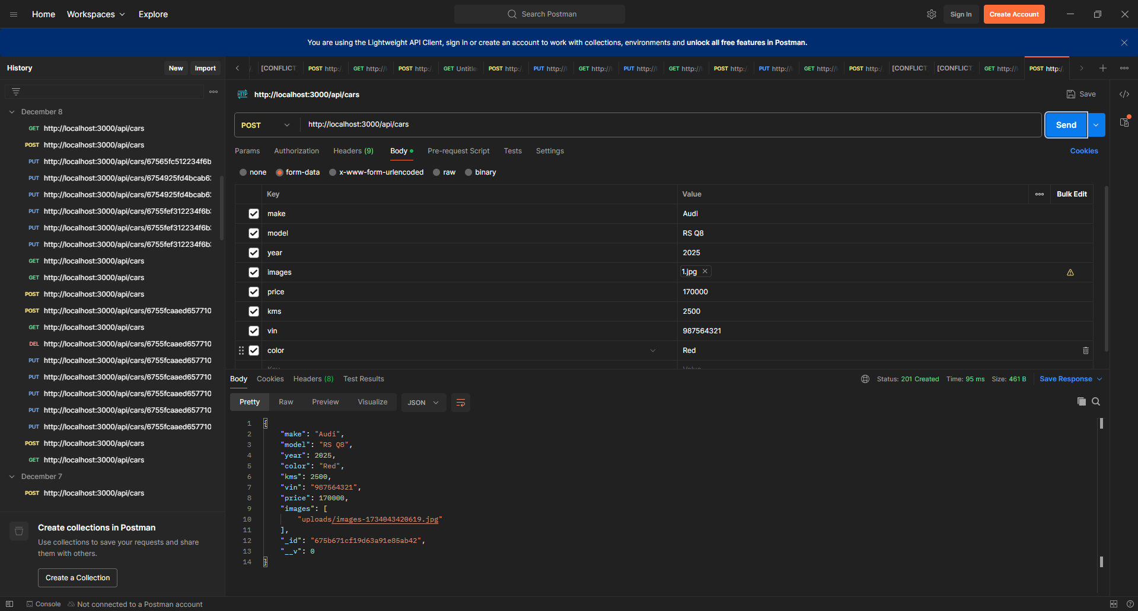
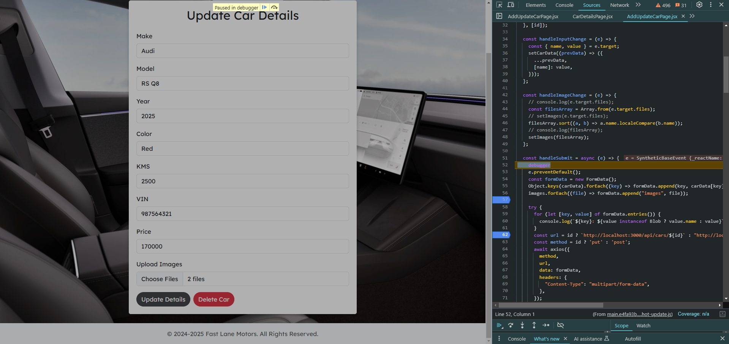
7. Future Improvements
- Add user accounts for personalization.
- Implement real-time inventory updates.
- Enhance the lease/finance calculator with additional options.

8. Challenges and Solutions
Challenges
- Handling large file uploads.
- Ensuring responsive design across devices.
Solutions
- Used Multer for file handling.
- Bootstrap for responsive UI components.

9. Conclusion
Summary
- FastLane Motors is a robust and scalable MERN stack project designed for efficient car dealership management.
Skills Gained
- Full-stack development expertise using the MERN stack.
- Deployment and debugging in a real-world scenario.

10. References
Documentation
- React Documentation: https://reactjs.org/docs/getting-started.html
- Node.js Documentation: https://nodejs.org/en/docs/
- MongoDB Documentation: https://www.mongodb.com/docs/
- Express.js Documentation: https://expressjs.com/
Libraries
- Mongoose Documentation: https://mongoosejs.com/docs/
- Body-Parser Middleware: https://www.npmjs.com/package/body-parser
- Multer File Upload: https://www.npmjs.com/package/multer
- CQRS Overview: https://martinfowler.com/bliki/CQRS.html

